**Fundamentals Of Programming**

Home Task 4

Name: Hussain Aun Ali

CMS: 463652

Section A

#include <iostream>

using namespace std;

int main(){

//Task 1: printing numbers from 1 to 150 except the multiples of ten

for (int i = 0 ; i<151 ; i++){

if (i % 10 == 0){

continue;

}

cout<<i<<endl;

}

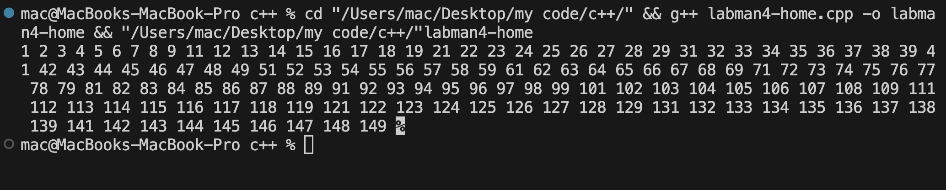

// Task 2: Adding the digits of an input number

int i;

cout<<"Enter a number: "<<endl;

cin>>i;

int num = i;

int l = 0;

while (num>0){

num = num /10;

l++;

}

int sum=0;

num = i;

for ( int s = 0; s<l; s++){

sum+=(num%10);

num = num/10;

}

cout<<"The sum of the digits is "<<sum<<endl;

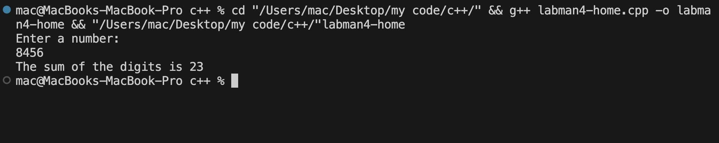

//Task 3: Checking whether a number is prime or not

int num;

cout<<"Enter a number: "<<endl;

cin>>num;

bool isPrime = true;

for (int s = 2; s < num; s++){

if (num%s == 0){

isPrime = false;

}

}

if (isPrime){

cout<<"Number is a prime number"<<endl;

}

else{

cout<<"Number is not prime"<<endl;

}

}

